**MA374-LAB5**

**Nikhil Agarwal**

**Roll:11012323**

1 a.

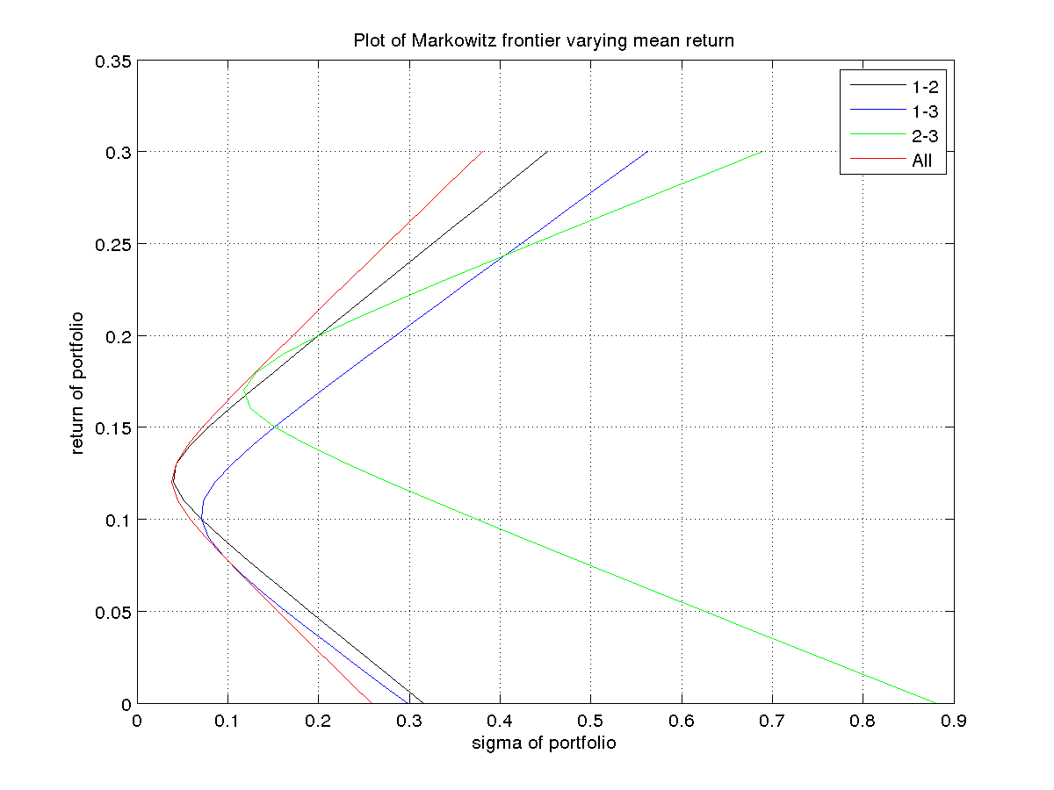

The feasible region is given by:

The weight equation is given by: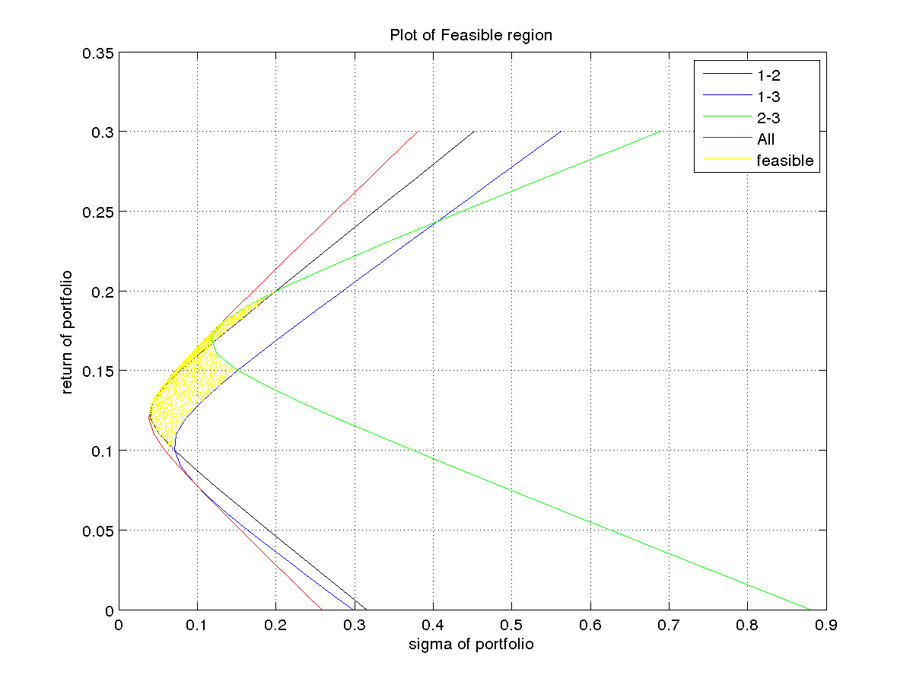

w1=278/109 - (1560*p)/109,

w2=(620*p)/109 – 49/109,

w3= (940*p)/109 – 120/109

where p is the return of the portfolio.

By plotting w1 vs w2 we get:

The intersection point of x+y=1 with w1 vs w2 shows that the value of w3=0 at that point.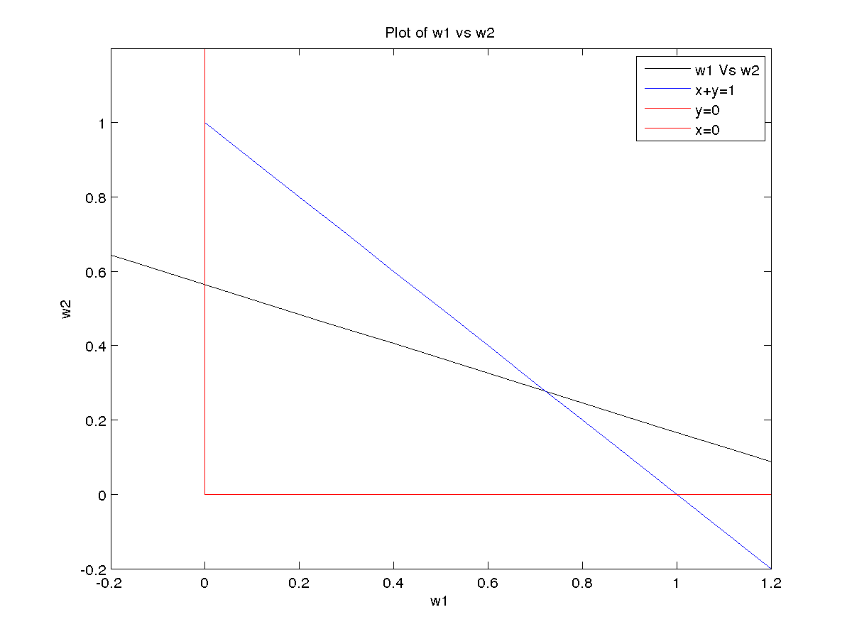

2.

Values of Beta for bse indexed for all 10 stocks are :

2.5924 7.8200 3.2783 20.4147 1.9642 6.4435 1.8478 4.8490 2.4868 0.0336

Values of Beta for bse non-indexed for all 10 stocks are :

1.2354 4.0483 -0.2759 -0.3363 0.5233 -0.0763 6.3481 4.0977 1.7560 4.5941

Values of Beta for nse indexed for all 10 stocks are :

5.1952 5.0821 4.1228 4.0638 1.9081 11.2026 8.0336 1.9682 1.8892 5.2775

Values of Beta for nse non-indexed for all 10 stocks are :

4.7400 0.7467 2.6398 0.6630 1.6079 3.7564 5.5485 0.3539 0.8213 5.6021

Values of Beta greater than 3 or 4 denotes highly volatile assets. The stocks having Beta greater than 1 denotes

stocks which are very strongly influenced by day-to-day market news, or by the general health of the economy. A negative beta simply means that the stock is inversely correlated with the market. When Beta is equal to zero, it simply means that movement of the asset is uncorrelated with the movement of the benchmark. When Beta is 1 movement of the asset is generally in the same direction as, and about the same amount as the movement of the benchmark while when beta is in between 0 and 1 , Movement of the asset is generally in the same direction as, but less than the movement of the benchmark.